What is digital wallet?

Digital wallet Is a cashless and contactless wallet used to collect the money received from vouchers which is based on the concept of e-RUPI. The digital wallet is not dependent on the banks. It is made in such a way that the people who is unbanked or limited to the internet, wallet presents a smooth and convenient method for beneficiaries to redeem services provided by government through e-RUPI.

How Does e-RUPI Operate?

* The corporate/Government Department (Sponsor) communicates information (specify fields such as name, cell phone number, amount, the purpose of the voucher, expiry date, and so on) with Issuer Bank to issue e-RUPI.
* The issuer bank/payer PSP submits a request to the NCPI (National Payments Corporation of India) to create an e-RUPI.
* NPCI sends a success confirmation notification to Issuing Bank/Payer PSP. The issuer bank/payer PSP certifies e-RUPI generation back to the corporate/government entity, which will then distribute the QR or SMS string to the recipient.
* The recipient receives the QR or SMS string in his wallet.
* If the QR or SMS is purpose specific then it will be saved in wallet. It cannot be redeemed.
* Beneficiary contacts merchant thru e-RUPI for redemption. Merchants validate e-RUPI vouchers, assess beneficiaries, and commence redemption requests.
* The merchant gives service to the recipient following successful redemption confirmation.
* If the QR or SMS message is not purpose specific not then can be redeemed in the wallet and we can use digital currency to transact from wallet to wallet.

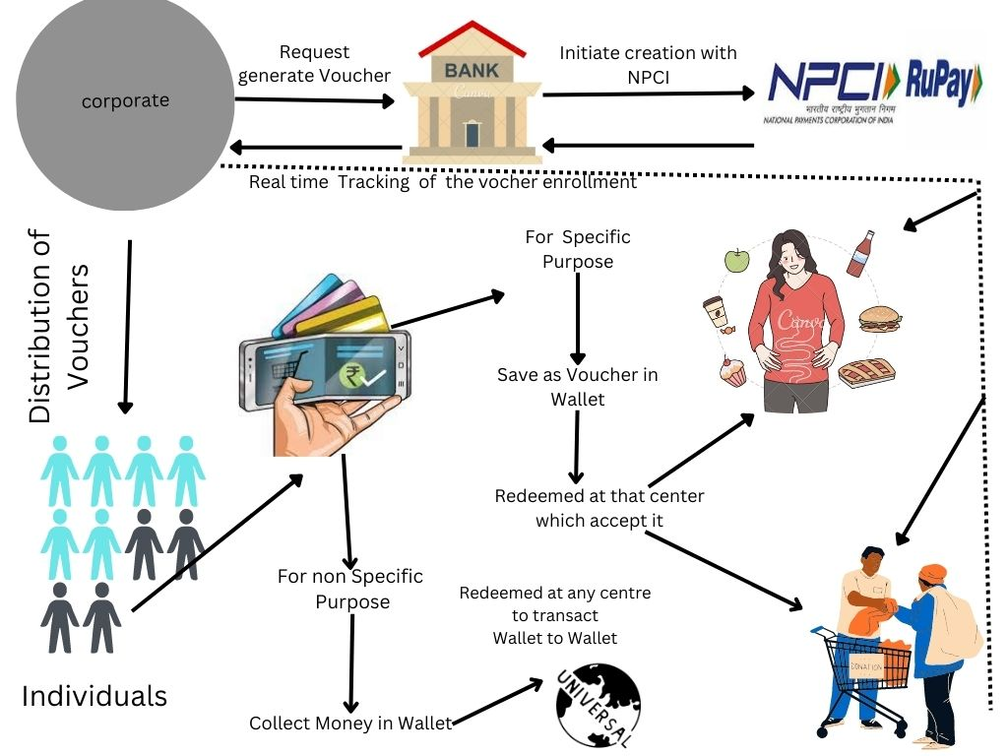

Benefits for Corporates:

* Corporates can enable well-being of their employees by distributing the e-RUPI Prepaid Vouchers which is collected in wallet.
* It is an end-to-end digital transaction and does not require any physical issuance (card/voucher) hence leading to cost reduction
* Visibility for voucher utilisation - Voucher redemption can be tracked by the receiver.
* Quick, safe & contactless voucher redemption and digital

Benefits for End-users:

* **Contactless** - Beneficiary need not carry a print out of the e-voucher
* **Easy redemption** - It is a 2-step redemption process
* **Safe and Secure** - Beneficiaries do not need to share personal details and hence their privacy is maintained
* **Only mobile phone and e-voucher required** - Users redeeming the voucher need not have a digital payment app or a bank account

